**Project Design Phase-II**

**Technology Stack (Architecture & Stack)**

|  |  |
| --- | --- |
| Date | 28 June 2025 |
| Team ID | LTVIP2025TMID36031 |
| Project Name | **Revolutionizing Liver Care: Predicting Liver Cirrhosis Using Advanced Machine Learning Techniques** |
| Maximum Marks | 4 Marks |

**Technical Architecture:**

The Deliverable shall include the architectural diagram as below and the information as per the table1 & table 2

**Reference:**[**https://liverfoundation.org/liver-diseases/complications-of-liver-disease/cirrhosis/**](https://liverfoundation.org/liver-diseases/complications-of-liver-disease/cirrhosis/)

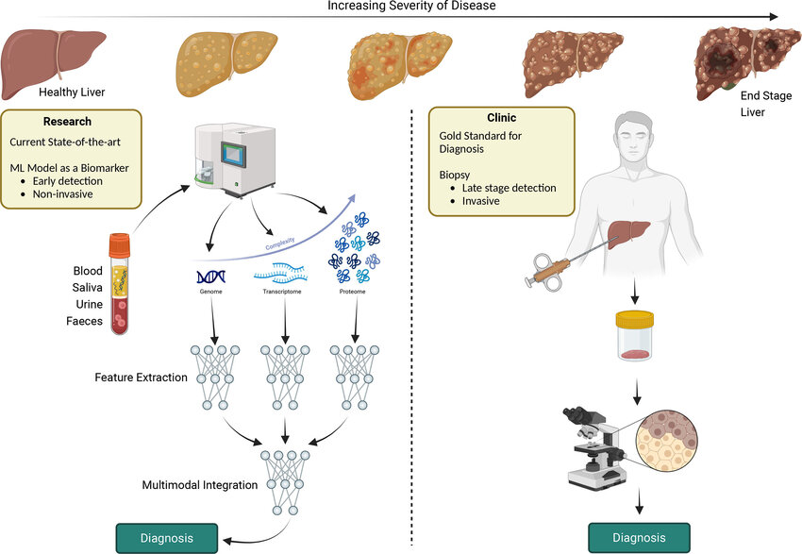

**Table-1 : Components & Technologies:**

|  |  |  |  |
| --- | --- | --- | --- |
| **S.No** | **Component** | **Description** | **Technology** |
|  | User Interface | Web and mobile interfaces | HTML, CSS, JavaScript, Bootstrap (Web), Flutter (Mobile) |
|  | Application Logic-1 | User input handling, authentication | Python, Flask |
|  | Application Logic-2 | ML prediction logic | Python, Scikit-learn |
|  | Application Logic-3 | User data and records | SQLite / MongoDB (Local) |
|  | Database | User data and records | SQLite / MongoDB (Local) |
|  | Cloud Database | Not applicable (local only) | ------ |
|  | File Storage | Upload & store reports locally | Local File system |
|  | External API-1 | Google login integration | Google OAuth API |
|  | External API-2 | (Optional, Aadhar/Hospital API) | ----- |
|  | Machine Learning Model | Predict liver cirrhosis | Custom ML Model with Scikit-learn |
|  | Infrastructure (Server / Cloud) | Runs locally on user system | Local Server (Flask + SQLite/MongoDB) |

**Table-2: Application Characteristics:**

|  |  |  |  |
| --- | --- | --- | --- |
| **S.No** | **Characteristics** | **Description** | **Technology** |
|  | Open-Source Frameworks | Used for backend and ML | Flask, Scikit-learn, TensorFlow |
|  | Security Implementations | Encrypted data, OAuth login | SHA-256, OAuth 2.0, Access Control |
|  | Scalable Architecture | Modular design supports future scaling | 3-Tier: UI → Logic → DB |
|  | Availability | Locally hosted but designed for minimal downtime | Local Server with monitoring |
|  | Performance | Optimized for fast predictions and data handling. | ML Inference, Indexed DB Queries |

**References:**

[**https://en.wikipedia.org/wiki/Cirrhosis**](https://en.wikipedia.org/wiki/Cirrhosis)

[**https://www.pathologyoutlines.com/topic/livercirrhosis.html**](https://www.pathologyoutlines.com/topic/livercirrhosis.html)[**https://emedicine.medscape.com/article/185856-overview**](https://emedicine.medscape.com/article/185856-overview)

[**https://www.sciencedirect.com/topics/nursing-and-health-professions/liver-cirrhosis**](https://www.sciencedirect.com/topics/nursing-and-health-professions/liver-cirrhosis)

[**https://www.msdmanuals.com/professional/hepatic-and-biliary-disorders/fibrosis-and-cirrhosis/cirrhosis**](https://www.msdmanuals.com/professional/hepatic-and-biliary-disorders/fibrosis-and-cirrhosis/cirrhosis)